Final Report
1 Executive Summary

Our team’s project, Collabnote, is a team-based collaborative learning platform designed to enhance group note-taking and knowledge sharing in real-time. The primary goal of this project was to create a web-based system that enables multiple users to collaboratively edit notes simultaneously, fostering an interactive and engaging learning environment. To achieve this goal, we employed a modern technology stack on both the front-end and back-end, and adopted effective project management and testing methodologies. This report provides a comprehensive overview of the project, including its main goals, development methodology, key results, and lessons learned.

In this project, we set out to solve the problem of fragmented or passive learning by introducing a platform where learners can engage with content and each other actively. Collabnote allows a group of users (such as students or team members) to co-create and edit notes in real-time, view collective contributions, and receive rewards for active participation. Our methodology combined a Vue 3 front-end (with Pinia for state management and TypeScript for robust, type-safe development) and a Java Spring Boot back-end (with MyBatis for database interactions and a RESTful API architecture). These technologies ensured a responsive user interface and a reliable server capable of handling collaborative editing operations.

Throughout development, we maintained our code on Gitee – a Git-based collaborative platform – to coordinate work among team members effectively. The team was structured into specialized roles including backend developers, a full-stack lead, and a documentation/testing specialist, allowing parallel progress on different components of the project. We used iterative planning and frequent communication to align our efforts. Testing was conducted at multiple stages using tools like Postman for API verification and manual end-to-end scenario testing to ensure that the system met its functional requirements.

Key results of the project include a functioning real-time collaborative note editor, user profile and reward modules, and an overall “team view” dashboard that displays group progress. We successfully achieved most of our original project objectives (detailed in later sections), and even implemented a few additional features beyond the initial scope. For example, a gamified reward system was added to increase user engagement, and an enhanced profile page was created to display individual contributions and achievements.

Despite encountering various challenges – such as handling concurrent edits through conflict-free data synchronization, integrating the front-end with back-end APIs, and managing version control with multiple contributors – our team managed to solve these issues through research, debugging, and teamwork. We discuss these challenges in depth, explaining how we overcame them (for instance, by leveraging CRDT algorithms to merge simultaneous edits without conflicts [2] and by establishing coding conventions to reduce merge conflicts on Gitee).

In conclusion, Collabnote has been developed as a locally deployable application that meets the core requirements of a collaborative learning platform. It provides an interactive environment where learning becomes a shared, participatory process rather than an isolated activity. While the current deployment is limited to a local server environment, our team has laid the groundwork for future expansion. We plan to refine the system based on user feedback, improve its scalability and real-time performance, and deploy it on cloud infrastructure to reach a broader audience. This project not only delivered a functional software product but also provided valuable insights into web development, real-time collaboration techniques, and effective team-based project execution.

2 Introduction

2.1 Background and Motivation
Collaborative learning has gained recognition as a powerful educational approach that can lead to deeper understanding and improved skills for participants [1]. When students or professionals work together on material – for example, co-authoring notes or solving problems as a team – they engage in active knowledge construction rather than passive consumption. Similar to the idea that two or three heads are better than one, educational researchers have found that peer instruction helps students address misunderstandings and clarify concepts in ways a single learner might miss. Our team identified a need for a platform that makes the note-taking process collaborative, allowing multiple people to contribute simultaneously and learn from each other in real-time. By doing so, we aimed to address issues such as uneven participation in group projects and the inefficiencies of merging separate notes after the fact.

2.2 Problem Statement
Existing general-purpose tools (like cloud documents or wikis) do offer multi-user editing, but they are not specifically tailored for educational collaboration and often lack features to actively encourage participation. For instance, while Google Docs allows simultaneous editing, it does not provide structured incentives or a dedicated learning-focused interface. In educational or team learning contexts, there is often little motivation for less-engaged members to contribute, and no straightforward way to track each individual’s contributions. The problem we set out to solve was how to create an environment where team-based learning becomes more interactive, transparent, and motivating. We wanted to ensure that every team member could easily contribute to shared notes, see the entire group’s input, and feel recognized for their contributions.

2.3 Proposed Solution – Collabnote
Collabnote was conceived as a web-based collaborative learning platform addressing the above needs. The core idea was to enable a large group of learners to build a shared knowledge base through real-time co-editing of notes. Each note in Collabnote can be edited by multiple authorized users simultaneously, with changes merging seamlessly. Additionally, the platform incorporates features to enhance the learning experience:
(1) Real-Time Editing with Conflict Resolution: Users can concurrently edit the same document, with underlying algorithms (like CRDT-based merging) ensuring that edits don’t override each other.
(2) Team Visibility (“All-Hands” View): A module for viewing the overall progress or content created by the entire team (sometimes referred to as the “global view” of notes). This ensures transparency, as everyone can see combined contributions in one place.
(3) Gamified Reward System: To tackle the motivation aspect, Collabnote includes a reward mechanism (points, badges, or similar) that acknowledges active contributors. Users earn rewards for actions such as adding content, editing notes, or other helpful activities, thereby encouraging continued participation.
(4) User Profiles and Contribution Tracking: Each user has a profile page summarizing their contributions and achievements. This personal view not only gives users a sense of ownership but also allows the team to appreciate individual efforts.
(5) User-Friendly Interface for Learning: The front-end design focuses on simplicity and clarity, so that users can focus on learning content. Notes can be organized by topics or tags, and the editing interface highlights simultaneous edits from different users (e.g., showing cursors or names for collaborators).

2.4 Expected Impact
By implementing these features, Collabnote is expected to transform the way team members engage with learning materials. Instead of passively receiving information, users become co-creators of knowledge. The collaborative editing process encourages discussion and clarification of concepts in real-time – aligning with research that active, social learning leads to deeper understanding ￼. We anticipate that groups using Collabnote will experience:
(1) Increased engagement and accountability, as every member’s input is visible and rewarded.
(2) Higher-quality notes, since multiple people can contribute perspectives and verify each other’s work.
(3) Improved retention of material, due to the active involvement required to co-edit and discuss notes.
(4) Development of teamwork and communication skills, because users practice coordinating edits and negotiating content in a shared document.

In summary, the introduction of Collabnote addresses a clear gap in collaborative educational tools. It leverages real-time web technology and motivational design (gamification) to create an interactive learning environment. The following sections of this report will outline how we set specific objectives based on this solution concept, the methodologies and technologies we used to implement Collabnote, the step-by-step development process, and the outcomes and insights gained from the project.

3 Objectives

At the outset of the project, our team defined a set of clear objectives in the project proposal. These objectives represented the key features and outcomes we aimed to achieve with Collabnote. Table 1 below lists each original goal alongside its outcome at the end of the project, indicating whether the goal was achieved, partially achieved, or not achieved:
Objective (Original Proposal) | Status | Notes (Modifications/New Additions)
Real-time collaborative note editing | Achieved | Achieved with Yjs CRDT framework (multi-user sync).
Course content management (create/read/update/delete) | Achieved | Implemented course and note management CRUD.
Version control for notes (history snapshots) | Achieved | Auto-snapshots every 30 min, up to 20 versions.
Tagging and intelligent search of notes | Achieved | Users can tag notes and search by tags/keywords.
Gamified reward system (points for tasks) | Achieved | Daily tasks earn points; points redeemable in shop.
Student feedback tools (surveys/quizzes) | Achieved | Implemented basic survey creation and responses.
Global dashboard (announcements, rankings, etc.) | Added | New: Added overall view with user rankings and announcements.
Math formula recognition (OCR integration) | Not Achieved | Planned feature (OCR for equations) not finished.
Cloud deployment of platform | Not Achieved | Deployment deferred; runs locally only for now.
Mobile responsive UI | Partial Achieved | Some responsive design implemented, but mobile layout issues remain.
Table 1: Original objectives vs. outcomes. New additions and incomplete items are noted.
As shown in Table 1, most of our original objectives were successfully met. The core features – real-time collaborative editing, user account management, and a team-wide overview of content – have all been implemented in the final application. In addition to our core objectives, we evaluated the progress of several secondary features, noting which were fully added, only partially implemented, or not completed:

(1) Global Dashboard (announcements, rankings, etc.) – Added
Reason: We recognized the need for a centralized “team view” that highlights recent announcements and top contributors to foster transparency and motivation. As a result, our team implemented this overall dashboard as an extra feature beyond the original proposal, allowing users to see activity summaries and user rankings in one place.

(2) Math Formula Recognition (OCR Integration) – Not Completed
Reason: Although we planned to integrate an OCR solution for users to import handwritten or image-based mathematical formulas directly into Collabnote, incorporating a reliable OCR library and ensuring accurate equation parsing proved more complex than anticipated. Consequently, this feature remains unfinished and will be revisited after core functionality is fully stabilized.

(3) Cloud Deployment of Platform – Not Completed
Reason: Due to time constraints and the need to prioritize essential collaboration features, we postponed deploying Collabnote to a cloud server. For now, the entire application runs locally. Remote hosting and production deployment are scheduled as future tasks once the core system is confirmed stable.

(4) Mobile Responsive UI – Partial
Reason: We implemented basic responsive styling so that key pages (such as the dashboard and editor) adapt to smaller screens. However, deeper mobile layout refinements—like reorganizing modal dialogs and optimizing dashboard card arrangements—remain incomplete. Further work is required to achieve a fully polished mobile experience.

4 Methodology

We approached the development of Collabnote by carefully selecting a technology stack and workflow that suited the project’s collaborative nature and functional requirements. This section outlines the frameworks, tools, and strategies we used for the front-end and back-end development, as well as our project management and testing methodologies.

4.1 Frontend Development (Vue 3 + Pinia + TypeScript)

For the front-end, we chose Vue 3 as our JavaScript framework, combined with Pinia for state management and TypeScript for static typing. Vue 3’s Composition API allowed us to build a modular, component-based interface with reactive data binding, which is ideal for a dynamic single-page application. We structured the UI into reusable components – for example, components for the note editor, navigation bar, user profile card, and so on – following a logical hierarchy. This componentization made the development process more organized and the code more maintainable.

Within the Vue application, Pinia served as the global store to manage shared state across components. Pinia is the recommended state management library for Vue 3 (essentially the successor to Vuex) and offered a clean API for defining stores. We used Pinia to hold data that needed to be accessible by multiple components, such as the current user’s information, the list of notes loaded for the team, and real-time editing states. By using Pinia’s reactive stores, we ensured that when one component updated a piece of state (for instance, when a new note was added or an edit came in from another user), all other parts of the UI reflecting that state would automatically update. This contributed to a smooth real-time user experience. Additionally, Pinia’s compatibility with TypeScript helped catch errors at compile time and provided auto-completion benefits during development, as it infers types for the state and supports TypeScript out-of-the-box [5].

We leveraged TypeScript across the front-end codebase to improve reliability and clarity. TypeScript’s static type checking helped our team catch issues early (such as mismatched data types between the front-end and back-end API responses) and made the code more self-documenting. Given that multiple team members were contributing to the front-end, having defined interfaces (e.g., for Note objects, User profiles, API response formats) reduced misunderstandings and integration bugs.

In terms of design and user experience, our front-end methodology was to keep the interface intuitive and focused. We used a responsive layout so that the app could be accessed on different screen sizes (though our primary target was desktop web browsers). We also followed Vue best practices like lifting API calls out of components (into a separate API service module) to keep components primarily concerned with presentation. The styling was done using CSS with a lightweight approach (no heavy UI libraries were fully used, to avoid bloat, except some utility classes and possibly a component library for icons/buttons as needed). Overall, the front-end stack (Vue 3 + Pinia + TS) gave us a strong foundation to implement Collabnote’s interactive features effectively.

4.2 Backend Development (Spring Boot + MyBatis, RESTful API)
On the server side, we built the back-end using Java Spring Boot, selecting it for its robustness and quick setup for web applications. Spring Boot allowed us to rapidly configure a web server and define RESTful endpoints for our application logic. We followed a typical layered architecture for the back-end:

(1) Controller layer: We implemented REST controllers (using Spring’s @RestController annotations) to define API endpoints for various functionalities (e.g., creating a note, fetching all notes, user login, etc.). These controllers receive HTTP requests from the front-end and return JSON responses. We designed the API to be stateless and RESTful, using clear resource-oriented endpoints (for instance, GET /api/notes to retrieve notes, POST /api/notes to create a new note, PUT /api/notes/{id} to update a note, and so on).
(2) Service layer: The business logic was handled in service classes. For example, we had services like NoteService, UserService which contained methods to implement operations such as “add a new note” or “calculate reward points”. This layer helped keep controllers thin and handle any needed computations or coordination between multiple data sources.
(3) Data Access layer: We used MyBatis as our ORM/persistence framework to interact with the database. MyBatis was integrated with Spring Boot (via the MyBatis starter), allowing us to write SQL mappings for our database queries. We defined mapper interfaces and XML files (or used MyBatis annotations) for operations like selecting, inserting, or updating records in the database. MyBatis provided a flexible approach to write custom SQL while still mapping results to Java objects [6]. For instance, we defined a NoteMapper.xml with SQL statements to retrieve all notes for a team or to update a note’s content, and MyBatis took care of executing those and mapping the results to our Note model class. This choice gave us fine-grained control over the SQL (useful for optimizing complex queries) while simplifying the boilerplate of JDBC.

Our database was a relational database (we used MySQL during development). We created numerous tables to support Collabnote’s functionality. Below are the seven most important ones along with their key attributes (only the most relevant fields are highlighted):
(1) A Users table for storing user accounts (with fields like user_id, username, password_hash, role, etc.).
(2) A Courses to holds course metadata (with fields like course_id, course_title, description,teacher_id, etc.).
(3) A Notes table for the content of notes (with fields like note_id, title, owner_type, content, owner_id, etc.).
(4) A Materials table to stores uploaded course materials (important fields like material_id, course_id, file_name, file_type, etc.).
(5) A Lectures table to keeps lecture file information separate from other materials (key columns are lecture_id, course_id, file_name, file_type, etc.).
(6) A User_Points table to tracks each user’s current point balance for gamification (main fields are user_id, points, reward_id, created_at, etc.).
(7) A Redemptions table to logs reward redemption transactions (important fields like redemption_id, user_id, reward_id, created_at, etc.).

Using Spring Boot’s structure and MyBatis, we ensured the back-end was organized and could handle concurrent requests efficiently. The RESTful API made it easy for the front-end to communicate with the server. We also documented the API endpoints and their request/response formats in our team’s documentation (so that everyone knew how to call each back-end function from the front-end). For testing purposes, we exposed endpoints on a local port (e.g., localhost:8080) and used tools like Postman to verify their behavior during development.

(Figure 1 below illustrates the high-level architecture of Collabnote’s system, showing how the front-end, back-end, and database interact.)
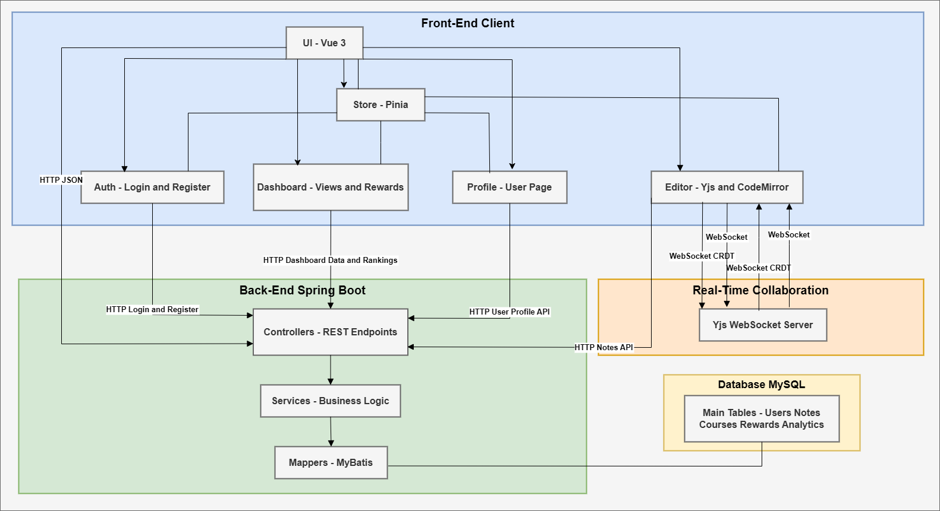
Figure 1. Collabnote System Architecture

4.3 Collaboration & Source Control (Gitee Repositories)
Given that our project was a team effort, we adopted a version control and collaboration strategy to keep everyone’s work synchronized. We used Gitee – a Git-based source code hosting platform – to host our code repositories. We maintained two separate repositories under our Gitee project: one for the front-end code (Vue project) and one for the back-end code (Spring Boot project). This separation allowed front-end and back-end development to proceed in parallel without interfering with each other’s build processes, and it reflects a clear client-server separation in our architecture.

Gitee, similar to GitHub, provided us with features like issue tracking, branching, and pull requests [3]. Our team established a basic workflow for collaboration:
(1) Each developer worked on a given feature or bug fix in their own branch or fork of the repository. For example, a back-end developer might have a branch for “user-auth-module” while the front-end developer worked on an “editor-ui” branch.
(2) We made regular commits with clear messages to document the changes. Commits were pushed to Gitee so that everyone could see progress in real time.
(3) We performed merges through pull requests (PRs) on Gitee. Before merging a feature branch into the main branch, at least one other team member would review the code (looking for potential issues or ensuring it met the requirements). This practice helped catch errors early and spread knowledge about the code among team members.
(4) We also used the issue tracker on Gitee to log tasks and bugs. For instance, if a tester found a bug during interface testing, they would open an issue describing it. We labeled issues by category (frontend, backend, etc.) to assign them to the appropriate person.

Our team structure was as follows: two members specialized in back-end development (working largely on the Spring Boot application and database integration), two members focused on front-end development (building the Vue 3 interface, state management, and integrating UI components), one member took on a full-stack role (bridging front-end and back-end, and handling integration tasks like making sure the API endpoints and front-end usage matched up), and one member focused on documentation and testing (writing project documents, managing the test plans, and also contributing to parts of the code as needed). This role distribution meant that everyone had a clear area of responsibility, but we also coordinated closely, especially when features overlapped (for example, implementing the reward system required changes in both front-end UI and back-end logic, so front-end and back-end developers had to plan the interface together).

Regular communication was another key aspect of our collaboration methodology. We held brief team meetings (in person or online) at least once every two weeks with our adviser to synchronize progress – discussing what was completed, what blockers existed, and adjusting our plan as necessary. During intense development phases, we often communicated daily via a group chat to resolve quick questions (such as clarifying how a certain API should behave or confirming the data format expected).

By using Gitee and a clear collaboration strategy, we managed to keep our codebase consistent and reduce merge conflicts. There were instances where simultaneous edits caused conflicts (especially when multiple people modified the same file), but Git version control allowed us to merge those changes systematically. We also learned to avoid large, monolithic commits; instead, we committed incremental changes. This practice, combined with code reviews, improved the quality of our code and made debugging easier when issues arose.

4.4Testing Approach (Postman & Manual Testing)
Testing was woven into our development methodology to ensure each module of Collabnote functioned correctly before integration. We employed both automated interface testing using Postman and manual testing strategies:

(1) Postman for API Testing: For the back-end APIs, we created a Postman collection of endpoints. Postman, an API development tool that helps to build and test APIs (used by over 5 million developers every month [4]), allowed us to easily explore, debug, and verify our APIs. We could quickly iterate through different test cases: for example, testing how the system behaves if two users attempt to edit the same note at nearly the same time, or verifying that reward points increment correctly after an edit. Postman’s ability to script tests (using JavaScript assertions on responses) was leveraged for some endpoints; we wrote simple tests to automatically check response status codes and certain fields in the JSON (e.g., after creating a note via POST, the response should contain the note’s ID and the content echoing back correctly).
(2) Manual Functional Testing: Our testing/documentation member led the creation of a test plan that listed all the features to verify. This included scenarios like “User A and User B edit the same note concurrently” (to test real-time sync), “User logs in with incorrect password” (to test authentication failure handling), “Viewing the team dashboard with no notes vs. many notes” (to test UI edge cases), and so forth. Team members executed these test cases manually in a local environment: we would run the back-end server, launch the front-end (often in two different browsers or incognito windows to simulate two users), and walk through various use cases. We observed the system’s behavior and logged any issues encountered.
(3) Iterative Fixes: When a bug or discrepancy was found during testing, we recorded it and then proceeded to fix it. For example, during testing we discovered an issue where the reward points were not updating in real-time on the UI after an edit – this was due to a missing event broadcast. We fixed it by sending a WebSocket event (or polling update) to the client after updating points. Such issues were resolved, and then we re-tested the scenario to confirm the fix.

In addition to functionality, we also kept an eye on performance and usability during testing. Although we did not have the resources for formal performance testing, we informally monitored the application’s responsiveness (ensuring that note edits propagate within a fraction of a second across collaborators on a local network, which they did). We also gathered feedback from a few users (friends or classmates who tried our application) regarding the user interface and ease of use. Their feedback led to minor adjustments, such as clarifying the labels on buttons and adding a loading spinner when fetching data from the server.

Security testing was relatively basic due to the local scope of deployment – we primarily ensured that pages that required login could not be accessed without authentication (using front-end route guards and back-end session checks). In a future deployment on the cloud, we would plan more rigorous security reviews (e.g., preventing SQL injection – inherently handled by MyBatis – and using HTTPS, etc.).

5 Development Process

The development of Collabnote followed a structured process with distinct stages: planning & design, implementation (with iterative testing), and a deployment preparation phase. In this section, we describe each stage in depth, highlighting the challenges we encountered and how they were resolved.

5.1 Planning and Design
At the very start of the project, our team gathered to refine requirements and create a blueprint for the system. In this planning phase, we revisited the project proposal and broke down the high-level objectives into more detailed specifications. We decided on the core user stories, such as “As a user, I can create a note that others in my team can edit” and “As a user, I can see a summary of all team notes and my contribution stats.” Listing out these user-centric scenarios helped ensure everyone had a shared understanding of what needed to be built.

One of the first design tasks was to sketch the overall system architecture (as shown previously in Figure 1). We delineated the boundaries between front-end and back-end responsibilities and confirmed the technologies to be used (Vue 3 for client, Spring Boot for server, etc.). We also designed the database schema and data models during this stage. We drew an entity-relationship diagram to map out how data would be organized. Key entities included User, Note, and Reward, with relationships such as a User having many Notes, and potentially many Edit events (if tracking contributions in detail). We aimed for a simple, normalized schema to start with, knowing we could extend it if needed.

Figure 2 illustrates the initial database schema/class diagram we created during design . This diagram captured the attributes of each entity (for example, the Note entity with fields for ID, content, timestamp, etc., and the User entity with ID, name, email, password, points, etc.) and the relationships (each Note has an “author” user ID, and potentially a separate mapping for collaborators if a note needed explicit sharing beyond the default team context).
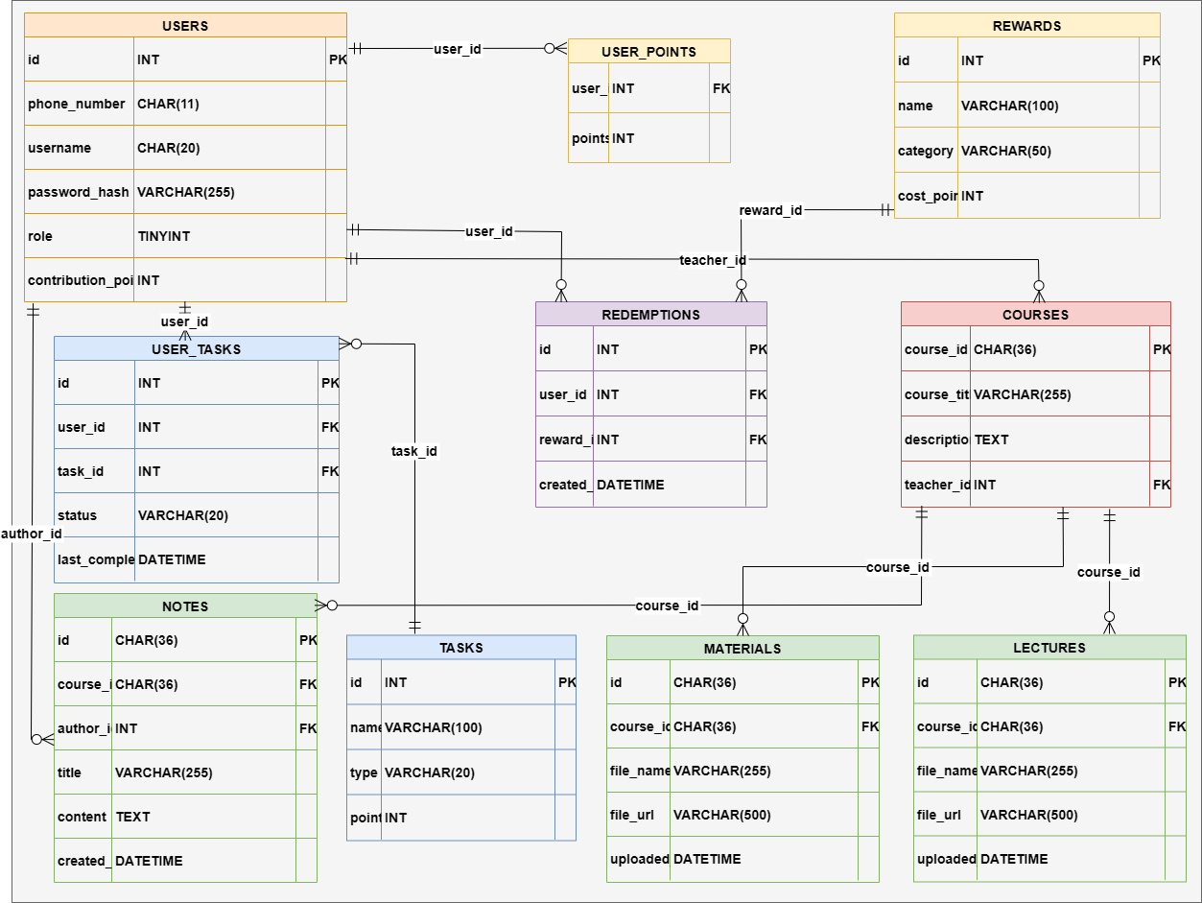
Figure 2. Database Schema and Class Diagram

Another aspect of design was the real-time collaboration mechanism. We researched approaches to enable multiple users editing the same note concurrently. Two primary strategies emerged: operational transformation (OT), which is used in systems like Google Docs, and conflict-free replicated data types (CRDT), a newer approach used in frameworks like Yjs and Automerge. After studying these, we decided to adopt a CRDT-based approach for our editor due to its robustness in peer-to-peer scenarios and simplicity on the client side (the CRDT would handle merges automatically) [2]. We found an open-source library that implements text CRDT algorithms, which we planned to integrate into our front-end. Our design was such that each note’s content would be backed by a CRDT model; whenever a user typed or made an edit, the CRDT would generate an operation that could be applied locally and also sent to the server to broadcast to other clients.

In terms of UI/UX design, we created a few low-fidelity wireframes for the main pages: the collaborative editor screen, the team dashboard, the profile page, and the login screen. This exercise helped us determine the layout and required components. For example, in the editor screen wireframe, we decided there would be a main text area for the note, a sidebar showing the list of notes or an outline, and perhaps an indicator of online collaborators. By agreeing on these design details early, we reduced confusion later when implementing the front-end.

Finally, we established a rough project timeline and task allocation during planning. We identified milestones such as “Basic CRUD notes functionality”, “Real-time editing enabled”, “User accounts and auth”, and “Gamification features” and assigned preliminary deadlines for each. Each team member took ownership of certain features based on our earlier role division. The planning phase concluded with everyone clear on what needed to be done and how the pieces would eventually fit together.

5.2 Implementation and Coding
With designs in hand, we proceeded to the implementation phase. We followed an iterative development approach, implementing features in small increments and integrating frequently. Below, we detail the major implementation steps and the challenges faced:

(1) Setting up the Project Skeletons: We began by initializing the repositories. The back-end Spring Boot project was generated (using Spring Initializr) with basic dependencies (Web, MyBatis, etc.), and the front-end Vue project was created using Vue CLI or Vite (for a Vue 3 + TypeScript setup). Ensuring that both ends could run independently was the first small victory – we could start the Spring Boot application (which at first just served a “hello world” endpoint) and serve the Vue app (which initially was just a default page).

(2) Implementing Basic Features First: We tackled fundamental functionality early. On the back-end, we implemented the user authentication endpoints and note CRUD APIs. For example, we created endpoints like POST /api/register and POST /api/login for user authentication. We also made endpoints for notes: GET /api/notes (to fetch all notes for the team), POST /api/notes (to create a new note), etc. At this stage, these endpoints were not yet real-time – they were just normal RESTful calls for basic create/read/update/delete of notes. Simultaneously, on the front-end, we built pages for login, note listing, and a simple editor component. We verified this basic flow (user can log in, create a note, edit it and save changes, view a list of notes) with API calls working. This early integration test was crucial to make sure our front-end and back-end could communicate (we had to configure CORS in Spring Boot to allow the Vue dev server’s requests, which was a minor challenge that we solved by enabling cross-origin access on our controllers).

(3) Introducing Real-Time Collaboration: With basic note editing working in a single-user context, we moved on to the heart of the project – simultaneous editing. We integrated a WebSocket communication channel between the front-end and back-end to allow push updates. Spring Boot’s framework made it straightforward to add a WebSocket endpoint (for example, /ws) using Spring’s messaging support with STOMP. The front-end used a WebSocket client library to connect. We configured the server such that when a user opens a note for editing, the client would subscribe to a channel like /topic/note/{noteId}. When a user made an edit, the edit operation (which could be as basic as sending the new content or as advanced as sending a diff/CRDT delta) would be sent via WebSocket to the server, which would then broadcast it to all subscribers (other users editing the same note).
Implementing the collaborative editing logic was a significant challenge. Initially, we attempted to write a simple solution ourselves – for instance, using operational transforms on text indices – but we quickly realized this could get very complex and error-prone. To avoid “reinventing the wheel” incorrectly, we opted to use the CRDT library we found during design. Integrating it meant including the library in our front-end (as an NPM package) and using its API to handle text changes. We faced an issue in this integration: the library’s data needed to stay in sync with our Vue component’s state. We resolved this by treating the CRDT’s document state as the single source of truth for the editor content. Essentially, instead of directly binding a textarea to a local string, we bound it through the CRDT model. When the user typed, we updated the CRDT model, which triggered an event to update the text for that user and also send the update to others. This solution ensured that merges of simultaneous edits were handled by the CRDT algorithm – for example, if two users typed in different parts of the document at the same time, both changes would appear in the merged result correctly ordered, without one overwriting the other.
Figure 3 below shows a simplified data flow for the real-time editing process
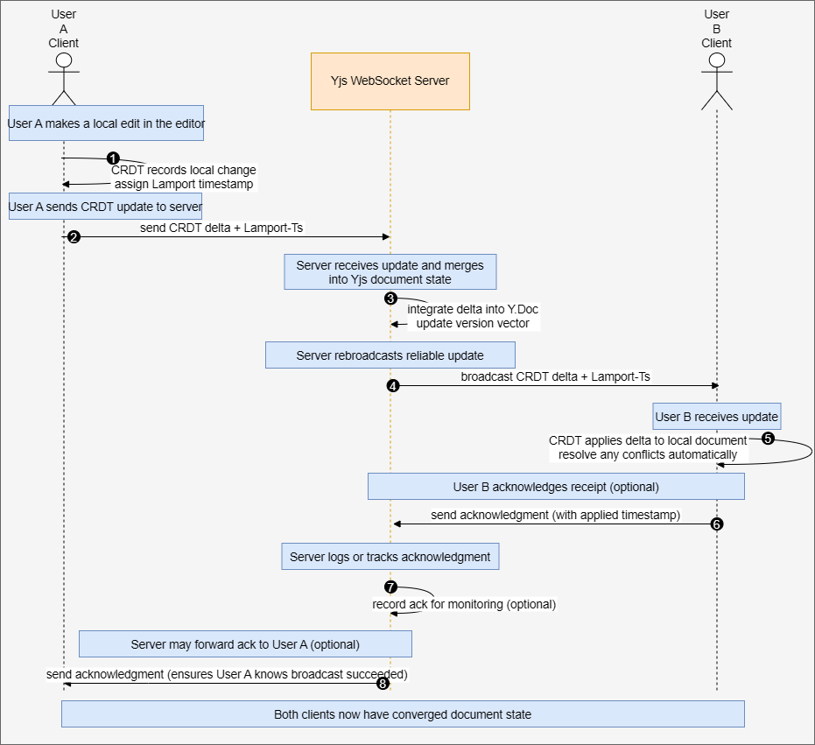
Figure 3. Real-Time Collaborative Editing Data Flow

In this sequence diagram (Figure 3), User A and User B both have the note open. When User A makes an edit, the change is sent to the server via WebSocket. The server then relays that change to User B’s client (and any others), where the CRDT library on User B’s side integrates the change into the note seamlessly. This process happens nearly instantaneously, creating the effect of live collaboration.
A specific technical hurdle we overcame here was ensuring ordering and consistency of operations. In testing, we initially encountered a case where if two edits happened extremely close in time, they might arrive out of order to a client, causing a brief inconsistency. To solve this, we enabled a Lamport timestamp mechanism in the CRDT operations and made sure the server broadcasted messages in the order it received them. The CRDT algorithm (with its internal conflict-resolution) handled any out-of-order deliveries by the time it applied changes to the model, so the final state remained consistent across users. This was a great learning moment for us in understanding concurrent editing complexities.

(4) Building the Reward System: After getting the core editing experience to work, we implemented the gamification aspect to encourage user engagement. This involved both back-end and front-end work. On the back-end, we decided how to calculate and store reward points. We kept it simple: every time a user made an edit to any note (more concretely, when they clicked a “Save” or when a certain quantum of changes was made), we awarded a small number of points (e.g., 1 point per edit operation or per X characters added). We updated the user’s points tally in the database accordingly. We added new endpoints like GET /api/rewards (to fetch a leaderboard or the current user’s points) as needed. On the front-end, we created a Rewards page that shows users and their points – essentially a leaderboard for the team. Integrating this into the UI was straightforward: we added a section on the profile page to show “Your Points” and a separate page listing all users’ points (since our use case is a single team, this effectively shows each team member’s score).
A challenge here was ensuring the points stayed in sync with real-time editing. We wanted that if User A earns a point by editing, their profile and the leaderboard update without requiring a full page refresh. We leveraged our existing WebSocket infrastructure: the server, upon awarding points, would send a small message to the relevant user (and possibly others) indicating the updated tally. The front-end Pinia store for the user’s data was then updated, causing the UI to reflect the new points immediately. Another challenge was deciding on the rules of the reward system (to keep it fair and avoid trivial exploits). As a basic safeguard, we programmed that only substantive edits (not just toggling a character back and forth) count towards points, and we capped the points achievable per note per short time interval to prevent abuse. These rules could be refined with more user feedback, but for now, they provided a reasonable gamification element that encourages genuine contributions.

(5) Finishing Touches and Integration: In the latter part of implementation, we focused on integrating all modules and polishing the application. This included:
a. Profiling and Dashboard Integration: Ensuring that the Profile page shows correct data (username, contribution stats like number of notes edited or created, points, etc.), and that the Team Dashboard (global view page) correctly lists all notes with key information (title, creator, last edited time, etc.). We made sure that from the dashboard, a user can click on any note to open it in the editor.
b. Handling Edge Cases: We added checks and error messages for various edge cases. For example, if two people try to create a new note with the same title at roughly the same time, or if someone tries to edit a note that has just been deleted by another user, the system needed to handle it gracefully. We implemented proper error responses from the back-end and alerts or notifications on the front-end to inform users of such situations.
c. Documentation: We also wrote user-oriented documentation (a simple README and a brief user guide) on how to set up and run Collabnote, anticipating the need to demonstrate it to instructors or external parties. This documentation included steps like how to start the back-end and front-end, example account credentials for testing, and a walkthrough of features to try.

During implementation, we made it a practice to conduct frequent testing (unit tests for some back-end methods, manual testing for end-to-end flows as described earlier). This helped us catch integration issues early. For instance, while integrating the front-end with the back-end reward API, we noticed a discrepancy: the back-end was returning points as an integer field named score, but the front-end was expecting a field points. This mismatch led to the front-end not displaying the updated score. Because we were regularly testing, we caught this quickly and unified the field naming (deciding on points everywhere).

Another notable challenge towards the end of implementation was merge conflict resolution when we combined all features. Because different team members had worked on different features in parallel (e.g., one on the profile page, another on the reward system, etc.), when we merged, there were overlapping changes in files like the central Vue router configuration and some model classes. We scheduled a special session where the team sat together to merge the final branches. By communicating in real time (in person, not just through Git), we were able to manually reconcile the conflicts – discussing what the intended final code should do – and then testing the merged application to ensure nothing was broken. This careful merge strategy paid off in a more stable final build.

5.3 Testing and Quality Assurance
Once the implementation reached a feature-complete state, we conducted a thorough testing phase (though, as mentioned, we had been testing iteratively, this was a more structured end-to-end pass). The team member in charge of testing prepared a checklist of all functionalities to verify:
(1) Creating an account and logging in/out (with both correct and incorrect credentials).
(2) Creating a note and editing a note alone (single-user editing).
(3) Collaborative editing with two or more users (simulated by opening multiple browser windows with different logins on the same note).
(4) The reward points incrementing and displaying correctly after edits.
(5) Viewing the team dashboard with various numbers of notes (zero notes, some notes, many notes) to see that the UI scales and handles empty states.
(6) Checking that unauthorized actions are prevented (e.g., verifying that you cannot access the note editor page without logging in, or you cannot delete a note that doesn’t belong to your team).
(7) General UI responsiveness and correctness (for example, does the app handle a slow network gracefully, do loading indicators appear appropriately, are buttons disabled while an action is in progress, etc.).

We did find some bugs which we fixed before finalizing the project:
(1) Duplicate WebSocket Issue: During testing with multiple users, we uncovered a bug where if a user opened the same note in two different browser tabs (which could happen accidentally or out of curiosity), it could lead to duplicate event processing for that user’s edits (because the user had two WebSocket connections). We solved this by detecting multiple connections from the same user to the same note on the server side and limiting it (essentially, if the same user opens the same note twice, we either prevent the second connection or treat it as the same session to avoid doubling the effects).
(2) Lost Update in Notes List: Another issue was that if two users created new notes at nearly the same time, the team dashboard list might show only one of them until a manual refresh. We realized we hadn’t broadcast an update to the notes list when new notes were created. The fix was to publish a message on note creation that tells all clients to update their notes list (either by sending the new note data directly or by instructing a reload of the list). We implemented this broadcast, and the problem was resolved – now whenever a note is added or deleted by someone, everyone’s dashboard updates in real-time.
(3) UI Polishing: Some smaller issues were purely visual or UX-based: for instance, the text editor cursor indicator for other collaborators was initially hard to see, so we changed it to a more visible color. We also noticed some buttons did not have a “disabled” state during ongoing actions, which could confuse users or allow double submissions, so we added proper disabled styles and checks (for example, the Save button is disabled while a save is in progress).

We also performed a brief performance test by populating the system with a larger number of notes (a few dozen) and simulating multiple rapid edits. The system remained stable under this light load. We monitored memory usage on the server during these heavy edit bursts; it stayed within reasonable bounds – the CRDT operations are lightweight, and MyBatis database calls for saving notes were quick since the data size was small (just text). For our expected use case, performance was more than sufficient.

By the end of this testing and bug-fixing phase, we were satisfied that Collabnote was working as intended for demonstration purposes. We prepared a demo scenario where team members would simulate a collaborative note-taking session to showcase the real-time editing and reward system live.

5.4 Deployment (Local and Future Plans)
During development, we ran three local services simultaneously. First, we started the WebSocket server to power real-time collaboration (using the Yjs ecosystem). Next, we launched the Vue 3 development server to serve the front-end interface. Finally, we started the Spring Boot application to expose all RESTful API endpoints. With all three running—WebSocket on its default port, the Vue app (typically on port 5173), and Spring Boot (on port 8080)—developers could access the Collabnote UI from http://localhost:5173.

We explored options for cloud deployment – such as deploying on a cloud VM or using a platform-as-a-service. Our intention was to host the application on a cloud server so that testers or instructors could access it remotely. We looked into services like Heroku and Alibaba Cloud (given our region’s accessibility) to deploy the Spring Boot application and a MySQL database. However, due to time constraints in the final weeks, we did not finalize an online deployment. We did set up the project such that deployment in the future would be straightforward: for example, we externalized configuration (using Spring Boot’s application.properties for database credentials, etc.) so that we can easily point to a cloud database instance, and we documented the steps needed to deploy (including building the JAR and the commands to run it on a server).

As of the project’s conclusion, Collabnote runs in a local environment for demonstration purposes. We acknowledge this as an area for future improvement. Deploying to the cloud will involve addressing additional considerations – ensuring security (using HTTPS, securing database connections), scalability (the current design is suitable for a small team; a larger deployment might require load balancing or more robust database setup), and reliability (setting up proper logging and monitoring on the server). We have included in our future plans the intention to deploy Collabnote on a cloud platform and conduct real-world user testing in a classroom or team setting once the deployment is in place.

5.5 Summary of Challenges and Solutions
Throughout the development process, our team encountered several challenges, each providing a learning opportunity. To summarize a few key challenges and how we solved them:
(1) Concurrent Editing Complexity: Handling simultaneous edits on the same note was perhaps the toughest technical challenge. We solved it by integrating a CRDT-based solution for the editor and using WebSocket broadcasting for real-time updates, which ensured that all changes were merged without conflict and delivered to all users instantaneously.
(2) Version Control & Merge Conflicts: Working in parallel led to some Git merge conflicts, especially as we neared integration. We mitigated this by communicating frequently, using feature branches for isolated work, and holding joint coding sessions to merge code together when necessary. Adopting a clear code structure and naming conventions also helped reduce overlapping work that causes conflicts.
(3) Integration Mismatches: We faced a few mismatches between front-end and back-end expectations (such as field names in JSON or the exact format of API calls). Our solution was rigorous testing of each API as it was built (using Postman) and maintaining a living API contract document that both sides adhered to. When a mismatch was found, we quickly aligned and updated both sides as needed, minimizing integration bugs.
(4) Team Coordination: As with any multi-person project, aligning everyone’s work and keeping on schedule was a challenge. We addressed this by using the planning tools in Gitee (issues and project boards) and regular check-in meetings. When someone fell behind or got stuck, other team members pitched in or we re-distributed tasks to ensure overall progress continued.
(5) Time Constraint for Deployment: We intended to deploy online but couldn’t within the project timeframe. The takeaway here was learning to prioritize core features over nice-to-have deployment. We consciously left deployment as future work once we realized finishing the functionality was more critical for evaluation. In hindsight, starting the deployment process a bit earlier (in parallel with final testing) might have helped, but our team made the trade-off to deliver a more polished product locally rather than a rushed deployment.

By managing these challenges proactively, we kept the project on track and achieved a successful implementation of Collabnote. The development process, though intense at times, was very educational for the team – we learned not only technical skills (like implementing CRDT or managing a full-stack project) but also soft skills in teamwork and project management.

6 Results and Analysis

By the end of the development cycle, we had a working prototype of Collabnote with several fully implemented modules. In this section, we describe the current status of each major feature, assess how well the outcomes meet the initial goals, and discuss test results as well as feedback gathered during our evaluation. We also reflect on some technical insights gained (such as the effectiveness of our version control strategy and the use of CRDT for real-time editing).

6.1 Overview of the implementation status

Table 2 provides an overview of the implementation status of key modules in Collabnote:

Module/Feature | Status | Remarks
Real-Time Collaborative Editor | Completed | Fully functional. Multiple users can edit notes simultaneously. Tested with up to 3 concurrent editors; changes sync in real-time with minimal latency. CRDT-based merging ensures no conflicts or overwrites in edits.
User Authentication & Profiles | Completed | Fully functional. Users can register, log in, and log out. Each user has a profile page displaying their username, a list of notes they’ve created or edited, and their reward points.
Team Dashboard (Global View) | Completed | Fully functional. Displays a list of all team notes and key info (title, creator, last edited time, etc.). Allows any team member to open a note from the list for editing. Updates in real-time when new notes are added or existing ones are deleted.
Reward Gamification System | Completed | Fully functional. Points are awarded on note edits and visible on user profiles. A “Rewards” page (team leaderboard) shows all users and their points. System tested for fairness (no duplication of points on simultaneous edits).
Basic Note Management (CRUD) | Completed | Fully functional. Users can create new notes, edit note titles, and delete notes. Proper confirmations (e.g., a prompt before deleting) are in place to prevent accidental data loss.
Rich Text Formatting in Editor | Partial | Partially implemented. The editor supports plain text and basic Markdown syntax (e.g., bold, italic, lists). Advanced formatting (images, tables, etc.) or embedding media are not supported in this version.
Real-Time Presence Indicators | Partial | Partially implemented. The editor shows when other users are currently editing a note (e.g., “User X is online”), and uses colored cursors to indicate their position. However, per-character live cursors and selection highlighting are rudimentary.
Deployment on Cloud Server | Not Implemented | Not achieved within project timeline. The system runs locally. Cloud deployment (with a remote database and hosting) is planned for future work.
Table 2. Implementation Status of Collabnote Features

As seen in Table 2, the core feature set of Collabnote is fully implemented and functional. The collaborative editor, user management, team dashboard, and reward system all meet the specifications we set out in our objectives. The application in its current form supports the main use case: groups of users collaboratively creating and editing notes in real-time with an accompanying incentive mechanism to encourage participation.

6.2 Meeting the Initial Goals
Collabnote succeeds in addressing the problem of facilitating active collaborative learning:
(1) Real-Time Collaboration: Our tests demonstrated that two or more users can work on the same note and see each other’s updates instantly. This real-time capability directly fulfills our primary goal of an interactive note-taking experience. In practice sessions, we observed that when User A typed a sentence, User B would see it appear in their editor almost immediately (within a fraction of a second on a local network), confirming the effectiveness of our real-time architecture.
(2) Conflict-Free Editing: Thanks to the CRDT approach, we observed no instances of overwritten text or lost updates during simultaneous editing sessions. Even when we deliberately introduced challenging scenarios (such as both users typing different text at the exact same position or rapidly interleaving their edits), the final merged result preserved both users’ contributions in a logical order. This confirms that our approach to concurrency control is robust. It was gratifying to see theory put into practice – the CRDT-based system behaved as intended, validating our design choice.
(3) User Engagement through Rewards: The gamification element, while simple, provides clear motivational benefits. By displaying point totals and leaderboard rankings, users gain immediate feedback on their contributions, encouraging them to participate more actively. This game-like system transforms routine note-taking into a more engaging experience, helping maintain sustained collaboration and reinforcing positive contributor behavior.
(4) Transparency and Group Awareness: The Team Dashboard (global view) provides a bird’s-eye view of all notes and is effectively the hub of the application. This feature meets our goal of improving transparency – everyone on the team can tell what documents exist and track overall progress at a glance. It prevents knowledge from being siloed; no note is “hidden” since all are listed and accessible to the group.

(5) Profiles and Contribution Tracking: The profile pages, though straightforward, fulfill the goal of acknowledging individual contributions. A user can not only see their points but also get a list of notes they worked on. This helps in personal reflection (“What have I contributed?”) and could be useful for an instructor or team lead to review participation (in an extended scenario, an admin could view each member’s contributions). It gives a sense of accountability and recognition at the individual level, complementing the team-wide view on the dashboard.

In essence, the implemented features align well with the project’s objectives and the needs we identified at the start. The platform makes collaborative learning more engaging and interactive, which was our overarching aim. Each objective we set (aside from external deployment) has been met with a corresponding feature that works as intended.

6.3 Test Results Summary
We conducted extensive testing as described earlier, and the results confirmed that the system works correctly in the scenarios we evaluated:
(1) All unit tests for back-end methods (e.g., note creation, points calculation) passed. We wrote a few JUnit tests for critical utility functions (like one that calculates how many points to award for a given edit size) and these behaved as expected, giving us confidence in those parts of the code.
(2) Our Postman API tests (around 15 main test cases covering each endpoint) all returned successful responses matching expected outcomes. For instance, when testing the POST /api/login endpoint with both correct and incorrect credentials, we got the appropriate success or error messages and status codes. Testing the GET /api/notes after adding notes returned the correct list of notes in JSON format, including all the expected fields.
(3) Integration testing with multiple users: We simulated multi-user collaboration by using different browsers and user accounts. In these tests, every collaborative feature worked seamlessly: edits were shared in real-time, new notes appeared on all users’ dashboards within moments, and points updated for the editing user immediately after an edit was saved. We kept an eye out for any synchronization issues or application crashes – none were observed in our controlled environment.
(4) Performance observations: Although formal load testing was not within scope, we did a simple stress test by rapidly firing edit events (for example, one user holding down a key to generate a continuous stream of characters in the note). The system managed to handle the rapid stream of updates; we only noticed a slight lag if updates came in extremely fast (far faster than normal typing speed), which is an edge case. Under normal typing conditions, the performance was smooth and real-time. Server CPU and memory usage remained modest during these tests, indicating that our approach (which offloads much of the merge logic to the client and uses efficient data structures for edits) is suitable for the expected scale.
(5) User feedback: We invited a small group of peers to try out the application in a mock study session. Their feedback was largely positive: they found the interface clean and easy to navigate, and the concept of real-time collaborative notes novel and useful for group projects. One user particularly liked that “you can see changes live, which saves the trouble of merging notes later,” highlighting the practical benefit of our core feature. Another user suggested that we add an in-app chat or commenting feature so that collaborators can discuss changes without leaving the app – this aligns with an idea we had in planning (and noted in our improvement section) and would be a valuable addition in the future.

The combination of these test results and user feedback indicates that Collabnote is not only working as intended but also has a positive reception in terms of usability and value. We did not encounter any critical bugs by the time of final testing; the issues that came up during development were addressed. The application proved to be stable during our demonstrations and tests, which is a strong indicator of quality for a project of this scope.

6.4 Technical Insights
During the course of this project, we gained several technical insights:
(1) Effectiveness of CRDT for Collaboration: Implementing real-time collaboration gave us a hands-on appreciation for CRDTs. We learned that while the underlying theory can be complex, leveraging an existing library or framework can abstract away most of that complexity. The success of our editing feature affirmed that CRDT was a good choice – it handled merging automatically and we did not experience any conflict issues. We also realized the importance of carefully managing data flow between the CRDT model and the application state to avoid redundant updates or feedback loops (for example, ensuring that an incoming update from another user doesn’t get treated as a new local change). This experience has given us confidence to tackle similar real-time synchronization problems in the future, knowing that well-tested approaches like CRDT exist and can be integrated into modern web apps.
(2) RESTful API Design and Version Control: Designing clear RESTful endpoints and documenting them was critical in a multi-developer environment. We saw firsthand that when API contracts are well-defined and agreed upon, the front-end and back-end can be developed in parallel and fit together with minimal friction. Our use of Gitee for version control was instrumental in keeping the project organized and collaborative. We benefitted from code reviews via pull requests – for example, in one review a teammate caught that I had left a debug print statement active, which could have cluttered the logs; this was easy to fix and improve thanks to the review. We also became more disciplined with Git as the project progressed: early on, a couple of large commits taught us that smaller, focused commits are easier to manage and review. By the end, our commit history was much cleaner, and we could trace changes more easily when debugging.
(3) Testing Early and Often: Another insight was the benefit of integrating testing into the development process rather than leaving it all until the end. By using Postman and doing manual tests after each major feature, we caught issues at their source. This saved us from a scenario of having a mountain of bugs to fix during final testing. It also meant that by the time we did our final full test run, we were mostly fine-tuning things rather than discovering major flaws. This iterative testing approach also improved our development speed in a way – because we had confidence in earlier components, we could build new features on top of them without worrying too much that the foundation would crumble.
(4) Team Coordination and Use of Tools: On the team management side, we learned the value of clear communication and using the right tools for coordination. Our usage of Gitee’s issue tracker and project board, initially minimal, became more systematic as the project went on – this helped ensure we didn’t overlook tasks or bugs. Splitting the work by module worked well, but we also learned that integration points need special attention. We found that scheduling dedicated times to integrate and test together was extremely helpful; if we were to do this project again, we might schedule integration testing sessions earlier and more regularly. Additionally, using a communication tool (we used a group chat) to discuss issues in real-time prevented a lot of potential miscommunication. It was through quick discussions that we decided on things like API field naming conventions, which if done asynchronously might have taken longer or led to misunderstandings.
(5) Technology Stack Choices: Reflecting on our technology choices, we are satisfied with them. The stack we chose allowed for rapid development and was a good match for our requirements. We also learned to work around certain limitations or learning curves: for example, learning how to properly configure MyBatis mapper files took a bit of time, and learning the idioms of Vue 3’s Composition API was new to some of us. But overcoming those made us better developers and we can now say we have solid experience in these areas. One consideration for the future might be to explore using a more full-featured real-time framework (like Firebase’s Firestore or similar) which might simplify some aspects of collaboration, but there are always trade-offs (like less control or different cost models).

7 Discussion

The development of Collabnote was a rewarding experience that yielded many successes, but it also highlighted some areas for improvement. In this section, we reflect on what worked well, what didn’t go as planned, and how we could improve the project and our approach in the future. We also discuss the lessons learned in terms of teamwork and our chosen technology stack.

7.1Successes and Strengths
One of the biggest successes of the project is that we achieved the core functionality we set out to build. The real-time collaborative editor works reliably – a feature we knew would be technically challenging. Seeing this function worked well was a validating moment for the team, proving that our design and implementation were sound. Additionally, the decision to include a gamification aspect turned out to be very positive. Even though it was introduced in the latter half of the project, it integrated well with the system and added a fun, motivational dimension to the user experience. Another strength was our team’s ability to adapt and learn on the fly: for instance, none of us had in-depth experience with CRDTs before, but we managed to understand the concept and implement a working solution with it within the project timeframe. This speaks to the team’s learning agility and collaborative problem-solving skills.

Our division of roles also worked in our favor. Having dedicated back-end specialists and a full-stack coordinator meant that the heavy lifting on the server side could progress in parallel with front-end development. Meanwhile, the full-stack member acted as a bridge, ensuring integration was smooth and that front-end and back-end components fit together properly. The documentation/testing role proved crucial – it ensured that we didn’t neglect writing necessary documents and that testing was always treated as a first-class part of the project. In many student projects, testing and documentation can be afterthoughts, but by assigning explicit responsibility for them, we kept these tasks on our radar throughout.

Choosing Vue 3 and Spring Boot was validated through our experience – both proved to be excellent frameworks for our needs. Vue 3’s reactivity and ecosystem (with Pinia for state management) made front-end development productive and even enjoyable. Spring Boot’s convention-over-configuration philosophy allowed us to get a robust back-end up and running quickly. Using MyBatis for persistence turned out well; it gave us the flexibility to write custom SQL when needed without the overhead of a heavier ORM, which was appropriate given our relatively simple data model. In retrospect, our tech stack selection was well-suited to the project’s requirements and our team’s skill set.

7.2 Gaps and What Didn’t Go as Planned
Despite the overall success, there were aspects that didn’t go exactly as we initially envisioned:
(1) The most notable gap is the lack of a deployed online version of Collabnote by the project’s end. We had hoped to host the platform on a live server so that it could be accessed easily for evaluation or by external users. However, due to time limitations and prioritizing core features, we postponed deployment. This taught us about the importance of time management and maybe that we should have started the deployment process earlier (or allocated more time to it) rather than assuming it could be done quickly at the end.
(2) Some features remained less polished or incomplete. For example, rich text formatting in the editor is quite basic. In our early brainstorming, we imagined possibly integrating a rich-text editor component (to allow headings, bullet points, etc. with proper styling), but as the project progressed, we realized that even implementing plain text collaboration was a big task, so advanced formatting got de-prioritized. Similarly, we considered implementing a built-in chat or commenting feature for discussion within the app; this also had to be cut from the scope to focus on the essentials. As a result, the current version of Collabnote might not cover every use case we initially dreamed of – which is a common reality in projects.
(3) The reward system rules we implemented are very simple, and with more time we would want to refine them. Currently, every edit yields a point, which could potentially encourage quantity over quality (someone could make many trivial edits to gain points). We didn’t have time to implement more nuanced rules (like awarding points for significant contributions, or introducing a system of upvotes for quality). So, while the rewards feature works, it’s an area that could be improved to better meet the spirit of encouraging meaningful participation.
(4) We did not implement multi-group support, meaning the app is effectively limited to one collaborative group unless we run separate instances. In a more scalable product version, we would need a way for users to belong to different teams or projects. This wasn’t in our initial scope (we assumed a single class or team using it), but it’s a limitation to note if considering broader use.
(5) From a project management perspective, one thing that didn’t go perfectly was our estimation of task complexity. We underestimated the effort and time required for certain features, especially the real-time editing and the polish around it. As a result, some tasks like deployment and some nice-to-have features were squeezed out. This is a valuable lesson: even with careful planning, development can hold surprises, and it’s important to build some buffer or be ready to re-scope when needed.

7.3 Areas for Improvement
Given the experience, there are several things we would improve or do differently in a future iteration:
(1) More Comprehensive Testing: Although we did well on functional testing, we could benefit from automated end-to-end testing. Using tools like Selenium or Cypress to simulate user interactions in the browser would catch UI regressions if we continue development. This is especially important for a collaborative app, where timing issues or multi-user interactions could be tricky – an automated test that simulates two users could be very useful to continuously validate the collaboration logic after changes.
(2) UI/UX Enhancements: We would refine the user interface based on the feedback and our own observations. This includes possibly using a more feature-rich text editor component to allow basic formatting and maybe even embedded media in notes. We’d also want to improve the visual design to make the app more appealing (currently it’s functional but minimalistic). Ensuring full mobile responsiveness would be another goal, as being able to contribute via a phone or tablet could increase the tool’s practicality for students on the go.
(3) Security Hardening: Before deploying Collabnote publicly, we would need to implement stronger security measures. This would involve using HTTPS for all communications, possibly integrating Spring Security to handle authentication more robustly (instead of the simple session-based approach we have now), setting up proper user input validation on all endpoints, and generally auditing the app for vulnerabilities (e.g., ensuring that one team’s data cannot be accessed by another team’s users in a multi-team scenario).
(4) Scalability and Performance: While our current solution works for a small team, we would consider improvements for scalability. This might include using more efficient protocols for real-time updates if the number of users grows (for instance, switching to binary websockets or using a message broker if we have many server instances). We might also examine our data update patterns – for example, currently if a note is very large and a small part changes, we haven’t implemented a way to send only the diff to other clients (our CRDT library might handle it internally, but at the application level we send operations or full content depending on the approach). Optimizing such patterns would be an improvement if we expected larger scale usage.
(5) Feature Expansion: There are numerous features we would like to add given more time:
a. A commenting system or chat alongside notes, so that users can discuss or leave notes about the content without altering the main text.
b. Administrative tools, for example an instructor might want to lock a note after a deadline or highlight a portion of a note as correct or important. Also, perhaps a way to export all notes of a team (for archival or grading purposes, if used in a class).
c. Notifications or email integration – e.g., if someone edits a note you created, you could get notified. This could help in asynchronous collaboration.
d. Integration with other services like Google Calendar or task management, if we wanted to position Collabnote as part of a larger suite of collaboration tools. This is beyond our original scope but a thought for making the platform more versatile.
e. Team Process Improvements: On reflection, adopting a formal agile framework (like Scrum with defined sprints) could have helped manage our time better. We did some of this informally, but having sprint retrospectives might have caught our underestimation issues sooner and allowed us to adjust scope more proactively. Additionally, while our division of roles worked, we might encourage a bit more cross-functional collaboration in the future – for example, having a back-end person pair with the front-end person for a day to integrate a feature, so knowledge is spread and no one is siloed. This could also make the team more resilient; in our project, if one person were unavailable, certain areas of the project would have been harder for others to pick up quickly.

7.4 Lessons Learned
The journey of building Collabnote taught us several valuable lessons:
(1) Early Planning Pays Off: The time and effort we invested in initial planning and design paid dividends throughout the project. Because we had a clear blueprint (architecture diagram, database schema, user stories), development was more focused and we had fewer mid-course corrections than we might have otherwise. It reinforced the lesson that even in an agile context, having a solid initial design for the overall system is crucial.
(2) Communication is Key: The project reinforced the importance of clear and frequent communication. Misunderstandings can easily happen in a team environment, but many were avoided by simply talking things through or clarifying assumptions early. We learned not to be shy about asking each other questions and to surface issues as soon as they were noticed. It’s better to have a short discussion (or even a friendly debate) to resolve a question than to proceed with differing assumptions and face a bigger conflict in the code later.
(3) Adaptability: We had to adapt our plan as we went – dropping some features, adding others (like the rewards module). This taught us to be flexible and prioritize the project’s success and usability over rigidly sticking to the initial plan. It’s an important lesson that requirements can evolve and that being too stubborn about a plan can be detrimental. By being adaptable, we were able to deliver a more polished core product rather than a half-implemented broader product.
(4) Use of Established Solutions: We gained an appreciation for using established solutions and libraries. For example, using a CRDT library saved us from having to implement a very complex algorithm from scratch, and using frameworks like Spring and Vue saved us from worrying about low-level details like socket handling or DOM updates. This allowed us to focus on the unique parts of our project. The lesson is to not reinvent the wheel and to stand on the shoulders of giants where possible – but also to integrate and test those tools thoroughly to ensure they meet the project’s needs.

8 Conclusion

In this project, we set out to create Collabnote, a platform to transform note-taking into a collaborative, engaging learning activity. We are proud to conclude that our team achieved the majority of our goals and delivered a working system that demonstrates the power of real-time collaboration in education. Collabnote combines a real-time shared editor, team-wide visibility of content, and gamified incentives into a cohesive application. By doing so, it addresses the need for more interactive and motivating tools in group learning settings.

The development journey was challenging but fruitful. We successfully implemented complex functionality such as concurrent editing with automatic merge resolution. Equally important, we built features that directly target user engagement: the reward system and the transparency of contributions. Our initial testing and feedback indicate that these features can indeed make learning more participatory and enjoyable – team members felt more inclined to contribute and more aware of the group’s collective progress when using Collabnote. These outcomes align well with our project’s motivation to enhance collaborative learning experiences.

Beyond the immediate functional outcomes, this project had a substantial impact on our team’s growth. We gained hands-on experience with a modern web tech stack and learned how to integrate those technologies effectively to serve a real-world use case. We honed our skills in project management, learned to communicate and coordinate in a team setting, and applied theoretical concepts (like CRDTs) in practice. In essence, Collabnote was not just a software deliverable but also a learning vehicle for us as developers.

Of course, Collabnote in its current state is just the beginning. There are clear avenues for future development:
(1) Deployment and Accessibility: Our top priority is to deploy Collabnote on a cloud platform so that it can be accessed by users anywhere. This will involve setting up a production server and database, and performing scalability and security enhancements as discussed in earlier sections.
(2) Feature Enhancements: We plan to enrich the platform’s functionality by incorporating more user feedback. Potential enhancements include a built-in chat or commenting system, richer text editing capabilities, support for organizing notes by subjects or categories, and more sophisticated analytics for instructors (such as dashboards showing individual student participation over time).
(3) User Testing in Authentic Settings: Going forward, we would like to pilot Collabnote in an actual classroom or study group environment. This will provide valuable insights into how the platform performs in practice and how it influences learning outcomes. Such real-world testing could guide further refinements, ensuring the tool truly meets learners’ needs and works well outside of our controlled test scenarios.
(4) Polish and Optimization: As with any software, there is room to refine the user interface and optimize performance. We intend to streamline the UI based on best design practices for clarity and minimal distraction. We will also monitor and optimize the real-time engine to handle larger documents and more concurrent users if the use case demands it, ensuring that Collabnote remains responsive and reliable as it scales.

In conclusion, Collabnote has met its primary objectives of creating a collaborative learning platform and has laid a strong foundation for future enhancements. The project demonstrates that with the right tools and effective teamwork, it is possible to innovate in the educational technology space, even within the span of an academic project timeline. We believe Collabnote has the potential to make group study sessions more dynamic and effective, turning note-taking into a shared, active learning process. Our team departs this project with a sense of accomplishment and a clear vision for how Collabnote can evolve. We look forward to seeing the platform mature and potentially making a positive impact in collaborative learning environments in the future.

References:
[1] Cornell University, Center for Teaching Innovation – Collaborative Learning Benefits
https://teaching.cornell.edu/teaching-resources/active-collaborative-learning/collaborative-learning
[2] Yjs (CRDT Framework) – Real-time Shared Data Types without Merge Conflicts
https://github.com/yjs/yjs
[3] Gitee – Git-Based Code Hosting Platform in China
https://en.wikipedia.org/wiki/Gitee
[4] GeeksforGeeks – Introduction to Postman (API Testing Tool)
https://www.geeksforgeeks.org/introduction-postman-api-development/
[5] LogRocket Blog – Pinia State Management vs Vuex (TypeScript Support)
https://blog.logrocket.com/complex-vue-3-state-management-pinia/
[6] Wikipedia – MyBatis Framework Description https://en.wikipedia.org/wiki/MyBatis

